Subject: Russo

Date: 20210910

Bin Width: 1ms

Gaussian Kernel: 1000ms

Event: press

t_pre: -4000ms

t_post: 4000ms

Units: All

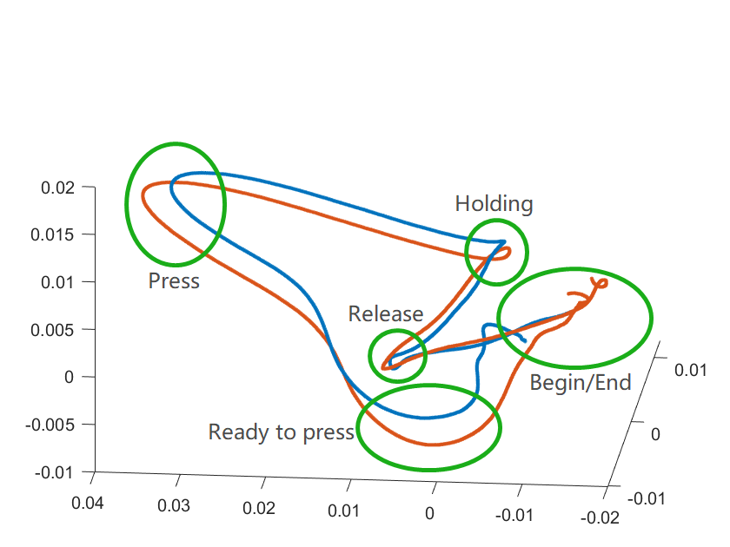

Blue: FP = 1500ms

Orange: FP = 750ms

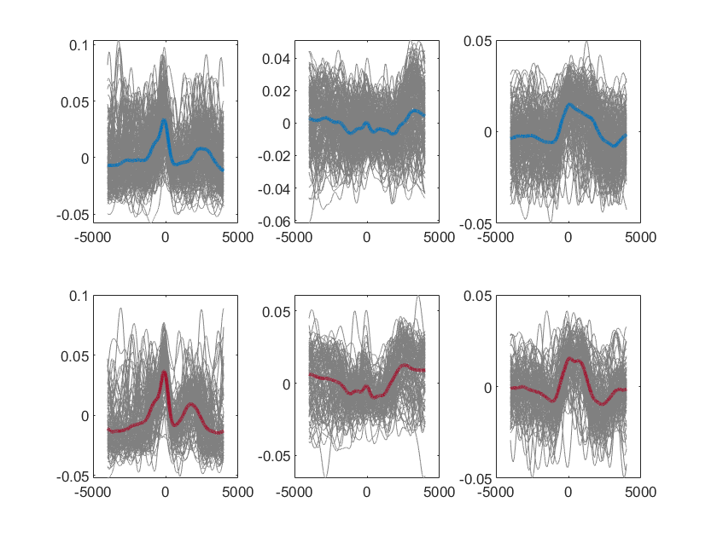

Top: PC1 / PC2 / PC3 vs t_press, FP = 1500ms

Down: PC1 / PC2 / PC3 vs t_press, FP = 750ms



PCA并不能有效地将数据降维，暗示着神经元放电具有一定的独立性。取Unit 1,2,4进行同样的操作，可以呈现出类似的效果。

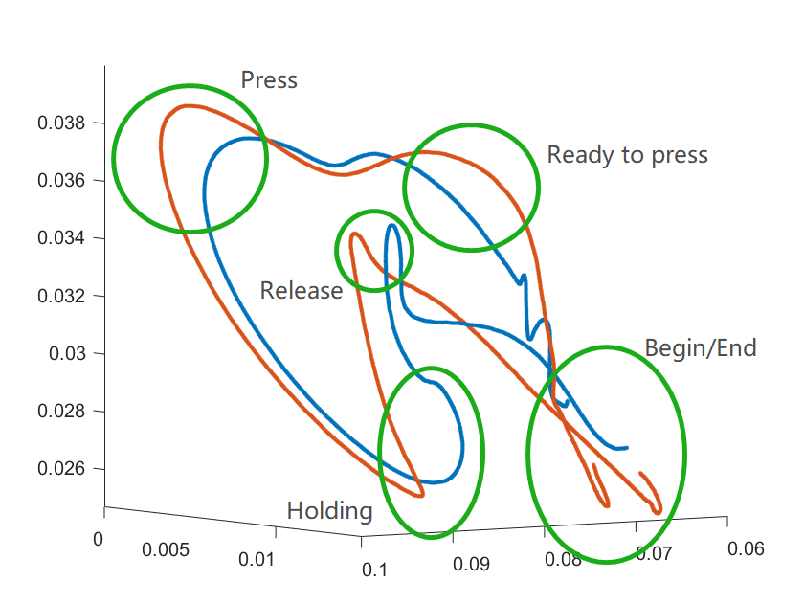

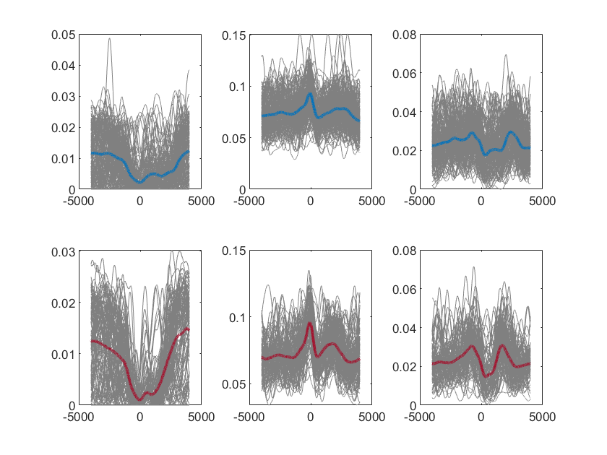

Correct trials are all alike; every false trial is false in its own way